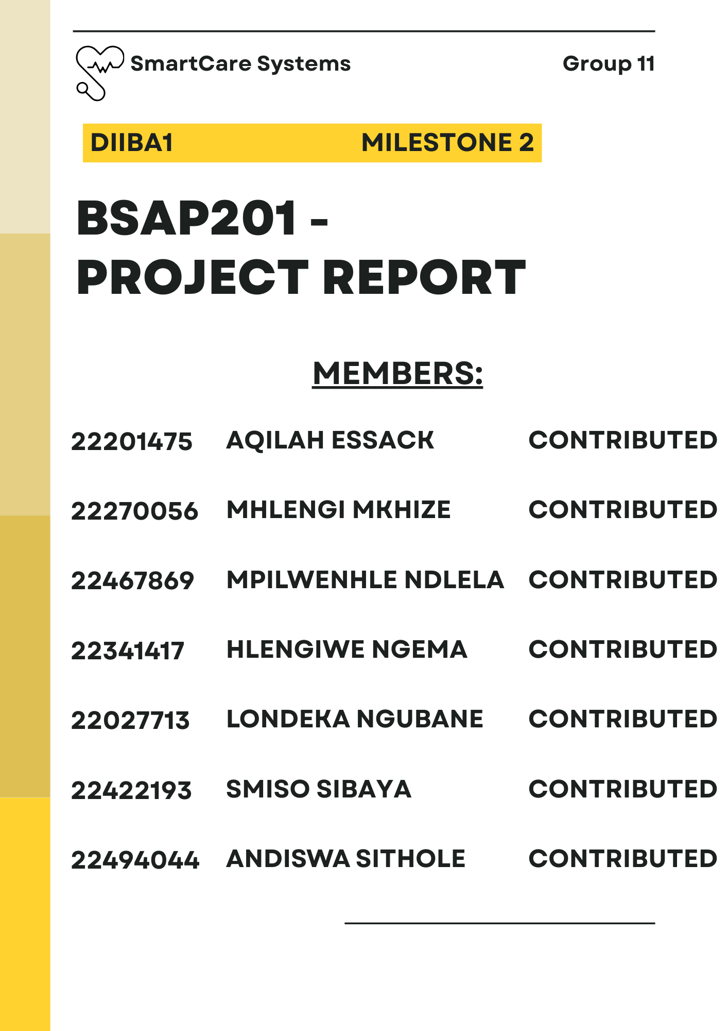

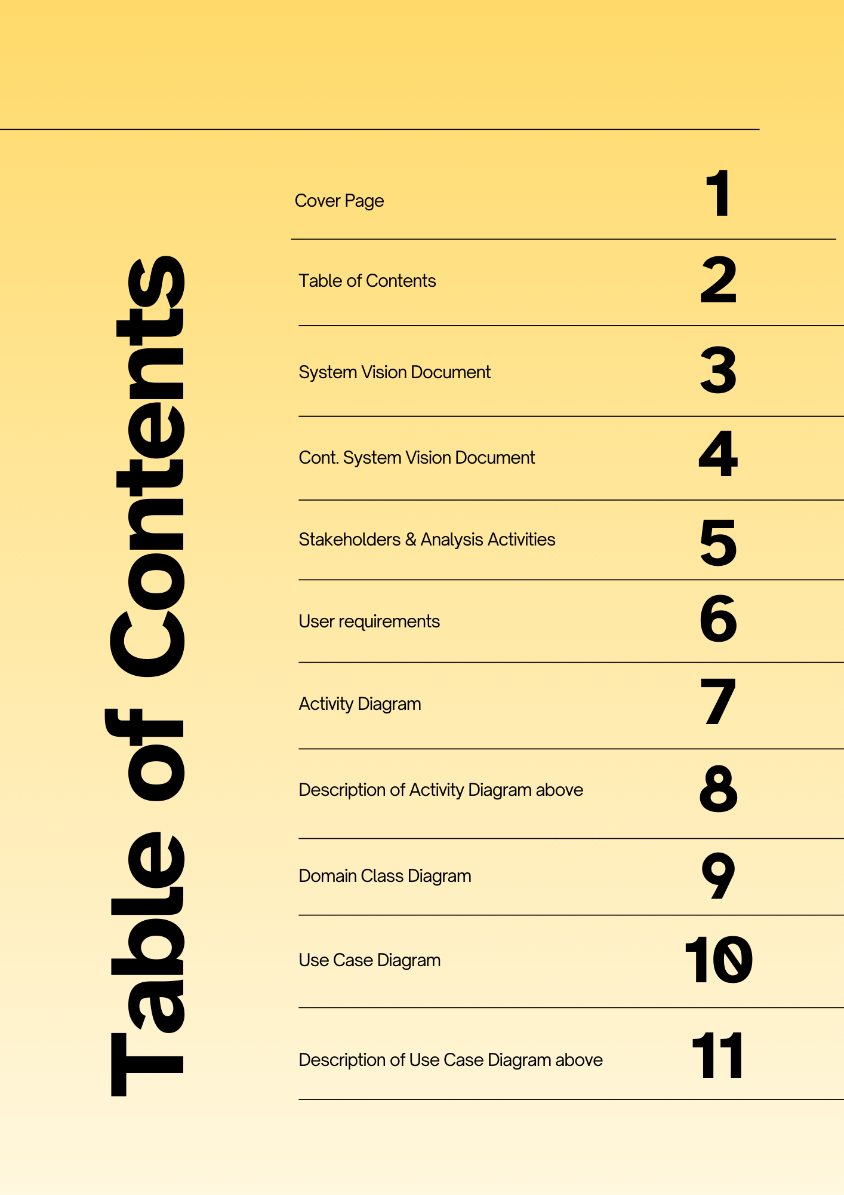

**System Vision Document**

**Clinic Patient File Management System – Glen Earle Clinic, Newlands East**

**1. Problem Description**

Glen Earle Clinic in Newlands East, Durban, is a small community healthcare provider that is still relying on a manual, paper-based filing system to store and manage patient records. Even though this method worked in the past, it is no longer effective since the clinic is growing and is serving more patients.

This filing method has made many difficulties for both staff and patients:

* Sometimes files are lost or misplaced, and this can lead to incomplete patient records.
* If there is a consultation, searching through files causes delay in a workday.
* By paper files been the record keeper, this is unreliable confidentiality as access is easily available to anyone.
* The files are only accessible at a certain place; this causes some inconvenience.

**Scenario example:** If a patient comes for a follow-up consultation, staff may spend up to 15 minutes searching for the correct file. Sometimes, the file may be missing, which then, the doctor treats the patient without a full medical history. This may cause frustration, longer waiting times, and risks of incorrect treatment.

This shows that the current file system is not meeting the business need for fast, secure, and reliable record keeping.

**2. System Capabilities**

The proposed digital patient record system will include the following capabilities:

* **Patient File Digitization** – Converting paper files into electronic files that are stored in a central database.
* **Secure Storage** – Protect patient data with passwords, encryption, and restricted access.
* **Quick Search** – Staff can retrieve files immediately by patient name, ID, or visit date.
* **Access Control** – Doctors, nurses, and admins shall have different levels of access.
* **Data Backup & Recovery** – Files will be backed up regularly to avoid missing of information.
* **Audit Trails** – Track who has used or updated records to improve accountability.

**3. Business Benefits**

After advancing the patient record system to an electronic system, Glen Earle Clinic will achieve many important benefits:

* **Better Patient Care:** Physicians will be able to make better treatment decisions since they will have access to complete and accurate information**.**
* **Faster Service:** Because records can be retrieved promptly, patients will have to wait less time.
* **Improved Security:** Only authorised personnel will be able to access password-protected records.
* **Lower Risk:** Patient records are protected against loss from mishaps, fires, and theft thanks to data backups.
* **Professional Image:** Patients have greater faith and confidence in the clinic's offerings thanks to a contemporary digital system.
* **Staff Efficiency:** By spending less time looking for files, staff members may devote more time to patient care.

**4. Stakeholders of the Patient Record System**

**Primary Stakeholders – Everyday Users**

* **Patients:** Demand that their records be accurate, safe, and easily available**.   
  • Physicians and nurses:** Access and update patient records on a daily basis using the system.   
  **• Administrative Staff (Receptionists**): In charge of scheduling appointments, maintaining patient records, and registering new patients.

**Secondary Stakeholders: Assistance and Supervision**

* **• Clinic Management:** Take charge of compliance, reporting, and operations.   
  **• IT developers and support personnel** are responsible for system development, upkeep, and troubleshooting.

**External Stakeholders: Compliance & Regulations**

* **• Health Department/Regulators:** Verify that POPIA and other healthcare regulations are followed by the system.

**5. Analysis Activities**

* **Requirements collection and analysis:** Staff surveys, observations, and interviews revealed important data that has to be kept on file, including as prescriptions, visit information, and patient histories.   
  **• Process Modelling:** To pinpoint delays and hazards, the existing paper-based workflow was mapped. A brand-new digital workflow was suggested as a solution to these issues.   
  **• Data Analysis & Entity Identification:** This process recognised entities like the patient, file, doctor, appointment, and their relationships (for example, a patient may have many appointments).

**6. User Requirements**

**Functional Requirements**

* Patient registration and file creation must be supported by the system.   
  • New visits, medicines, or treatments must be able to be added to patient records by staff members using the system.   
  • The system needs to make it possible to search patient files quickly and securely.   
  • Reports on patient visits and medical histories must be produced by the system.   
  • The system needs to support scheduling and managing appointments.

**Non-Functional Requirements**

* **Usability:** Employees with little computer experience should be able to easily use the interface.   
  **• Performance:** It should take the system two seconds to get patient records.   
  **• Security:** Audit trails, access control, and encryption are required for patient data. **• Reliability:** Data backup and recovery should be part of the system. **Compliance:** Needs to adhere to POPIA laws in South Africa.   
  **• Scalability:** As the clinic grows, the system ought to be able to accommodate future expansion.

**DESCRIPTION OF ACTIVITY DIAGRAM ABOVE**

From first access to actions taken after a visit, the activity diagram shows how a patient interacts with a clinic management system. After choosing to register or log in, you can search and filter doctors by date or speciality. Patients can choose to cancel or reschedule their appointments after viewing the available providers. Once confirmed, they show up for the appointment, and the doctor may give them feedback or amend their file. System audit logging and logout mark the end of the process.   
• Workflow displayed: Step-by-step patient contact with the system • Goal: To expedite appointment scheduling and visualise patient involvement   
•Important choices: Modifications to appointments and registration status   
• Last actions: audit trail, logout, file updates, and feedback   
This illustration promotes effective, patient-focused healthcare delivery.

**DESCRIPTION OF DOMAIN CLASS DIAGRAM ABOVE**

Our clinic management system's fundamental structure is depicted by the domain class diagram, which lists important entities and their connections. Each of the classes—Patient, Doctor, Appointment, Record, and Department—has pertinent characteristics. Multiple visits, each associated with a different doctor, can be scheduled by patients. Medical records with information on diagnoses and treatments may be created during appointments. Physicians are part of departments that group employees according to their areas of expertise. This graphic facilitates effective data organisation for departmental tasks, clinical recording, and patient visit management. It acts as a guide for database architecture, guaranteeing precise documentation of administrative procedures and healthcare interactions. The system encourages more efficient operations, improved patient care, and efficient use of resources in the clinic setting by simulating these interactions.

.

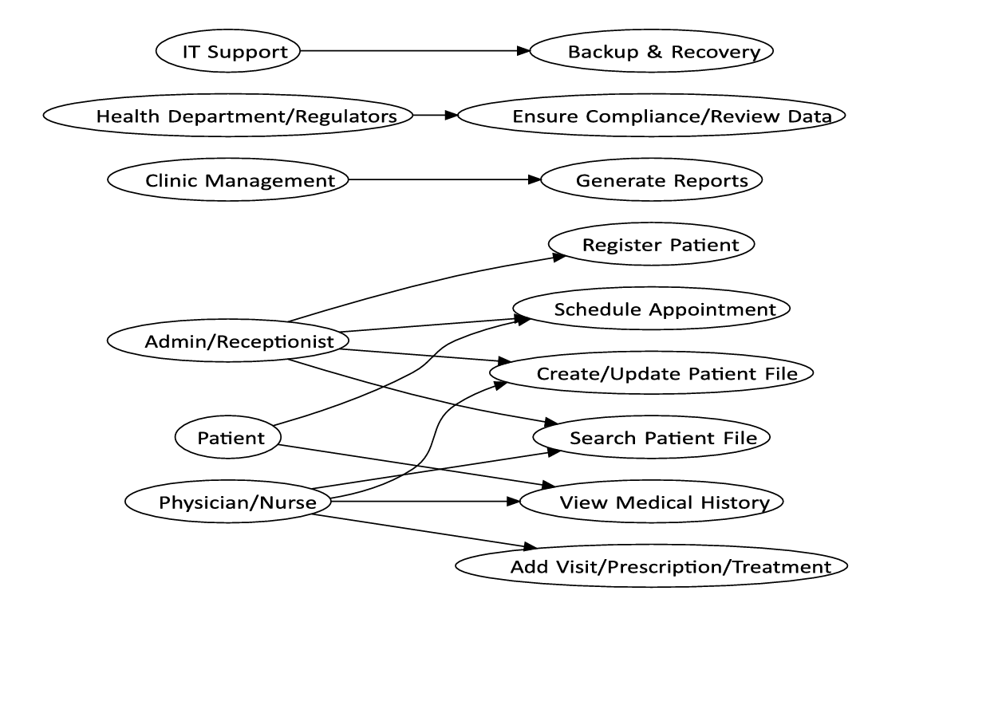

**DESCRIPTION OF USE CASE DIAGRAM ABOVE**

The use case diagram illustrates how several actors—such as the administrator/receptionist, the doctor/nurse, the patient, IT support, the health department/regulators, and the clinic management—interact with the system. It draws attention to the different interactions and tasks these actors carry out in order to provide effective patient care and manage clinic administrative responsibilities.

* Interactions between: the clinic management system and actors (users/entities) are displayed.
* The goal : is to handle administrative and patient care duties effectively.
* Participants included: IT Support, the Health Department/Regulators, the Patient, the Physician/Nurse, the Administrative Assistant/Receptionist, and the Clinic Management.